TCG Store Platform

# Introduction

This documentation contains all the plans to do with the creation of an online web based TCG store platform. Inside this document you will find a Use Case Diagram, use case narratives, a class diagram, entity relationship diagram and sequence diagrams. There will also be basic screen outlines and designs on how the website will look and feel before development begins. Each part will outline the structure and the plan on how to create the TCG store platform.

# Vision Statement

This project exists to create a platform to provide us with a way to see our collection of cards. The vision of this project is to create a visually appealing and easy to use store that customers will be able to create an order and get what they are looking for quickly. This will be accomplished by the integration of many different tools that when combined will create a strong platform for both customers and admins to use.

# Tools That are Planned to be Used

|  |  |  |
| --- | --- | --- |
| ASP.NET Core | <https://docs.microsoft.com/en-us/aspnet/core/?view=aspnetcore-3.1> | Handle the back-end code that will run the site |
| MS SQL Server | <https://www.microsoft.com/en-ca/sql-server/sql-server-2019> | Handle the database storage of the site |
| Identity Server | <https://identityserver.io/> | To provide user logins |
| Yu-Gi-Oh API | <https://db.ygoprodeck.com/api-guide/> | To provide the data for the Yu-Gi-Oh cards |
| Pokémon TCG API | <https://pokemontcg.io/> | To provide the data for the Pokémon cards |
| PayPal | <https://developer.paypal.com/docs/api/overview/> | Handle payment processing |
| React | <https://reactjs.org/> | Create the front-end design |
| Canada Post API | <https://www.canadapost.ca/cpotools/apps/drc/home?execution=e1s1> | Handle the estimation of shipping costs |

# Use Case Diagram

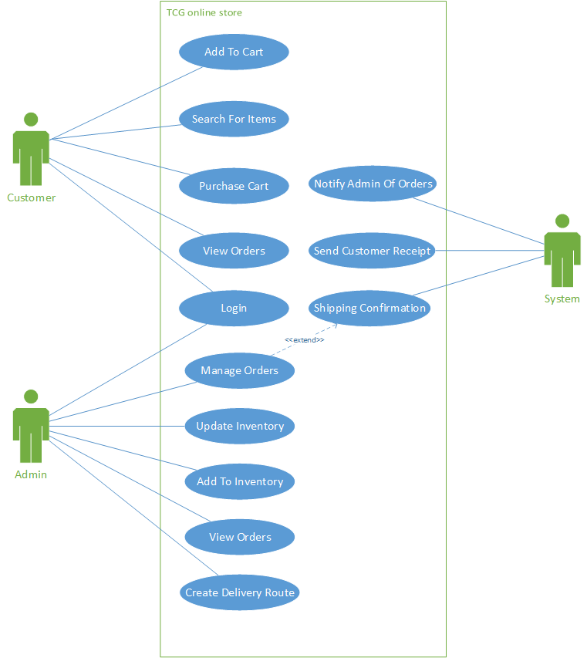

* System use cases may be wrapped into various admin and customer use cases as developing commences.

# Use Case Narratives

## Add to Cart

|  |  |  |
| --- | --- | --- |
| **Use Case Name:** | *Add to cart* | |
| **Description:** | *Customer is adding items to their cart* | |
| **Actor(s):** | *Customer* | |
| **Preconditions:** | *The customer is wanting to add an item to their cart.* | |
| **Normal flow of events:** | **Actor action** | **System Response** |
| *1. Customer clicks add to cart button* | *2. System processes the quantity of items and adds them to cart*  *3. System notifies customer the item was added to cart* |
| **Post-conditions:** | *Items are added to the customers cart.* | |

## Search for Items

|  |  |  |
| --- | --- | --- |
| **Use Case Name:** | *Search for items* | |
| **Description:** | *Customer is looking for items to purchase* | |
| **Actor(s):** | *Customer* | |
| **Preconditions:** | *The customer is wanting to search for items to purchase* | |
| **Normal flow of events:** | **Actor action** | **System Response** |
| *1. Customer enters their search query into the search bar*  *2. Customer confirms the search* | *3. System searches the database for the items that match the search*  *4. System displays to user the items that are in stock to the customer* |
| **Post-conditions:** | *The customer is displayed the items based on their search query.* | |

## Purchase Cart

|  |  |  |
| --- | --- | --- |
| **Use Case Name:** | *Purchase Cart* | |
| **Description:** | *Customer is looking to purchase the items in their carts* | |
| **Actor(s):** | *Customer* | |
| **Preconditions:** | *The customer is wanting to purchase the items they have selected in their cart* | |
| **Normal flow of events:** | **Actor action** | **System Response** |
| *1. Customer navigates to their cart*  *2. Customer selects purchase on their car*    *5. Customer views order details*  *6. Customer enters payment details and confirms orders* | *3. System Generates order total*  *4. System displays the order total and items to customer*  *7. System checks customer payments details*  *8. Systems notifies customer order has been placed* |
| **Post-conditions:** | *The customer has now placed an order and has been notified that is had been placed* | |

## View Orders

|  |  |  |
| --- | --- | --- |
| **Use Case Name:** | *View Orders* | |
| **Description:** | *Customer wants to view their order history* | |
| **Actor(s):** | *Customer* | |
| **Preconditions:** | *The customer is looking to view their order history and is on the order history page.* | |
| **Normal flow of events:** | **Actor action** | **System Response** |
| *1. Customer requests to view order history on the order history page* | *2. System searches for the customer order history*  *3. Displays the customer order history to the customer* |
| **Post-conditions:** | *The customer has been successfully shown their order history.* | |

## Login

|  |  |  |
| --- | --- | --- |
| **Use Case Name:** | *Login* | |
| **Description:** | *Customer or admin are looking to log in* | |
| **Actor(s):** | *Customer, Admin* | |
| **Preconditions:** | *The customer or admin are looking to log in to the TCG store. The user is already on the log in page* | |
| **Normal flow of events:** | **Actor action** | **System Response** |
| *1. Customer or admin fill out the log in details* | *2. System verifies the log in information is correct*  *3. Displays success and sends the logged in user back to the main page* |
| **Post-conditions:** | *The customer or admin has successfully logged into the website.* | |

## Manage Orders

|  |  |  |
| --- | --- | --- |
| **Use Case Name:** | *Manage Orders* | |
| **Description:** | *Admin is looking to manage all current orders* | |
| **Actor(s):** | *Admin* | |
| **Preconditions:** | *The admin is on the order management page and is looking to view all orders* | |
| **Normal flow of events:** | **Actor action** | **System Response** |
| *2. Admin finds the order they want to manage*  *3. Admin alters any information to do with the order and clicks save* | *1. System populates the page with all orders that are not completed*  *4. System updates the order information*  *5. System notifies the admin that the order has been updated*  *6. System notifies customer of any order changes* |
| **Post-conditions:** | *The admin has successfully managed an order* | |

## Update Inventory

|  |  |  |
| --- | --- | --- |
| **Use Case Name:** | *Update Inventory* | |
| **Description:** | *Admin wants to change the inventory numbers and details* | |
| **Actor(s):** | *Admin* | |
| **Preconditions:** | *The admin wants to change inventory numbers and details. The admin in on the inventory page* | |
| **Normal flow of events:** | **Actor action** | **System Response** |
| 1. *Admin selects the set to view*   *3. The admin updates the inventory details for an item in the stock*  *4. The admin saves the changes* | *2. The system displays all the inventory based on the set*  *5. The system processes the update of the inventory items*  *6. The admin is notified of the changes to the inventory* |
| **Post-conditions:** | *The admin has successfully update inventory* | |

## Add to Inventory

|  |  |  |
| --- | --- | --- |
| **Use Case Name:** | *Add to Inventory* | |
| **Description:** | *Admin is looking to add new items to the store’s inventory* | |
| **Actor(s):** | *Admin* | |
| **Preconditions:** | *The admin wants to add items to the inventory. They are already on the add inventory page* | |
| **Normal flow of events:** | **Actor action** | **System Response** |
| *1. Admin selects the set to add to inventory*  *3. Admin fills out details of items to be added*  *4. Admin submits the inventory to be added* | *2. System displays all results from the set*  *5. System saves the new additions*  *6. System notifies the admin the new items have been added to inventory* |
| **Post-conditions:** | *The customer is displayed the items based on their search query.* | |

## View Orders

|  |  |  |
| --- | --- | --- |
| **Use Case Name:** | *View Orders* | |
| **Description:** | *Admin is looking to view all current orders in the system* | |
| **Actor(s):** | *Admin* | |
| **Preconditions:** | *The admin is looking to view all the current orders in the system. They are already on the order page.* | |
| **Normal flow of events:** | **Actor action** | **System Response** |
|  | *1. System displays all the current orders in the system* |
| **Post-conditions:** | *The admin has successfully viewed all the current orders* | |

## Create Delivery Route

|  |  |  |
| --- | --- | --- |
| **Use Case Name:** | *Create Delivery Route* | |
| **Description:** | *Admin needs a delivery route created* | |
| **Actor(s):** | *Admin* | |
| **Preconditions:** | *Admin has orders that need to be delivered. They are on the order delivery page* | |
| **Normal flow of events:** | **Actor action** | **System Response** |
| *1. Requests a delivery route to be created* | *2. The system finds all due orders for the date of delivery*  *3. System generates the delivery route*  *4. System displays the delivery route to the admin* |
| **Post-conditions:** | *The admin has successfully obtained a delivery route* | |

## Notify Admin of Orders

|  |  |  |
| --- | --- | --- |
| **Use Case Name:** | *Notify Admin of Orders* | |
| **Description:** | *The system is needing to notify the admins of orders* | |
| **Actor(s):** | *System* | |
| **Preconditions:** | *A new order has been placed* | |
| **Normal flow of events:** | **Actor action** | **System Response** |
| *1. System sends order details* | *2. System collects all order details*  *3. System sends notification or the admin of an order* |
| **Post-conditions:** | *System has notified the admin of an order* | |

## Send Customer Receipt

|  |  |  |
| --- | --- | --- |
| **Use Case Name:** | *Send Customer Receipt* | |
| **Description:** | *A customer needs to receive a receipt of the order* | |
| **Actor(s):** | *System* | |
| **Preconditions:** | *A customer has completed their order that has been placed.* | |
| **Normal flow of events:** | **Actor action** | **System Response** |
| *1. System collects all the order information* | *2. System sends email to the customer about the items purchased* |
| **Post-conditions:** | *The customer has received their receipt of their purchase* | |

## Shipping Confirmation

|  |  |  |
| --- | --- | --- |
| **Use Case Name:** | *Shipping Confirmation (Extension of manage orders)* | |
| **Description:** | *System needs to update the shipping confirmation of an order* | |
| **Actor(s):** | *System* | |
| **Preconditions:** | *An order has been updated in it’s shipping status or delivery status* | |
| **Normal flow of events:** | **Actor action** | **System Response** |
| *1. System verifies that the order has been updated* | *2. The system updates the shipping or delivery status*  *3. System sends notification of the update to the shipping or delivery status* |
| **Post-conditions:** | *The system has updated the status of the shipping status* | |

# Entity Relation Diagram

# Class Diagram

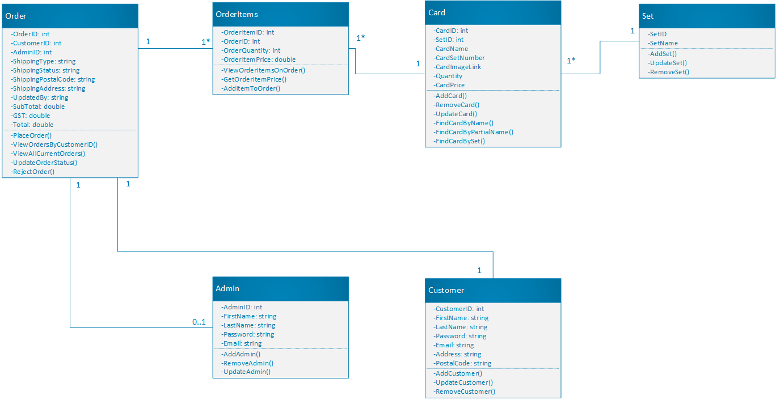

# Sequence Diagrams

## Add to Cart

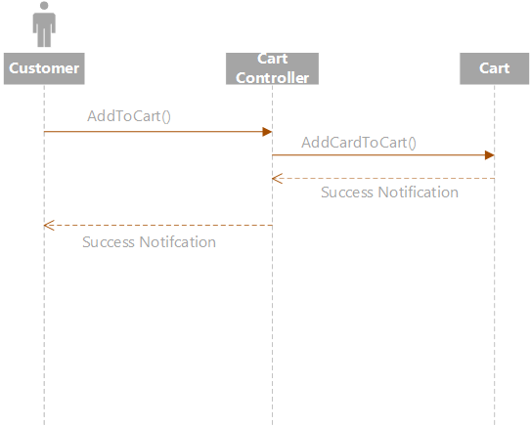

## Add to inventory

## Create Delivery Route

## Login

## Manage Orders

## Notify Admin of Orders

## Purchase Cart

## Search for Items

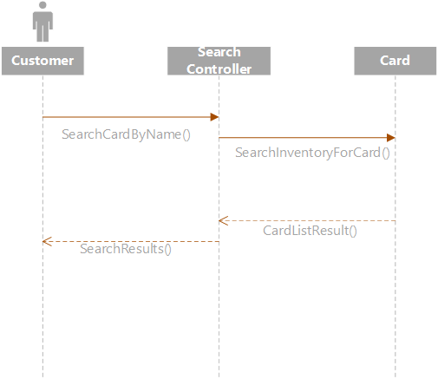

## Send Customer Receipt

## Shipping Confirmation

## Update Inventory

## View Orders

# Screen Designs

## Individual Card Info Page

Seen by all users. Both Customers and Admins

## Cart Popup

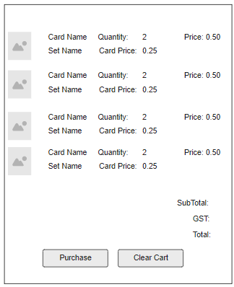

Seen by all users. Both customers and admins.

## Generate Delivery Route

Seen only by admins.

## Home Page

Seen by all users. Both customers and admins.

## Inventory Management Page

Seen only by admins.

## Inventory Addition Page

Seen only by admins.

## Login Page

Seen by all users. Both customers and admins.

## Order History

Seen by all users. Both customers and admins. Admins will see a different order history page closer to the order management page. Customers will only see their own orders to their one account.

## Order management

Seen only by admins. Admins will be able to mange the order status of orders and mark them as shipped or as out for delivery and if they are delivered.

## Purchase Order Page

Seen by customers and admins. Will be used by customers. This is where they will purchase the items in their cart. If the customer does not indicate the billing address if the same as the shipping address, they will be shown a second set of boxes to fill out their shipping address. The total box on the left side of the screen will flow with the user as they scroll.

## Search Result Page

Seen by customers and admins. This is the search results that a user submits in the search bar. This will show all results based on the search query a user inputs.

## Sign up Page

Seen by all users. Both admins and customers.